Building Classification Models with TensorFlow
Janani Ravi (ugh)

Much of this is redundant to the classification in sklearn course
also Janani is very repetititve
also this is using old version of python (2.7) → old course (2017)

KNN in tensorflow – much more manual than sklearn – distance measures implemented from scratch – comparisons implemented from scratch
- L1 distance – traversing blocks of grid
  - subtract individual x and y vals and sum the 2 results
  - other names: snake, city block, manhattan
- Euclidian (L2 distance) – sqrt of the squared sum of x val and y val differences
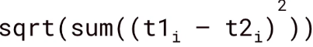
- numpy, scipy, pandas, matplotlib
- mnist data in tensorflow.example.tutorials.mnist.input_data
  - input_data.read_data_sets['mnist_data']
  - mnist.train.next_batch(#) to get records
- tf.reset_default_graph() - clear prior NN graph
- <deprecated> tf.placeholder(“float”, (None, 784)) temporary space for input data
- np.bincount – count number of occurrences of a value in an array
- tf.subtract two images then run tf.abs to remove sign (pos/neg)
- tf.reduce_sum to add the result – compare distance to every other image in the dataset
- tf.nn.top_k = sort the iamges and then return the N closest
- for testing – pass in each test image 1 at a time
  - calc accuracy for each prediction
- tf.layers.bucketized column = bin continuous values
- cross columns - tf.layers.crossed_column
  - combine two features (cross product) create all value colbinations

NN overview
- Affine transformation – linear part of neuron (Wx+b) weight and bias
- activation functions: RelU, logit, tanh, step
- weighted inputs and max used for output

Convolutional Neural Network (CNN)
- sparse NNs with 2D architecture
- image/text classification
  - sentiment analysis and NLP
- neuron local receptive field – portion of the data examined
- layer kinds – convolution and pooling
  - convolution – every layer focuses on only a part of the data
    - Kernel/Filter/feature detector = sliding window function applied to matrix
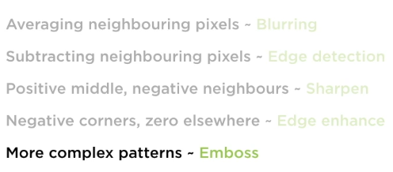
    - zero padding – add exra rows and cols of zeros aroudn the matrix such that relevant data is the center of a larger matrix before applying the kernel
      - ensure every matrix element passes into the filter
      - determined by problem
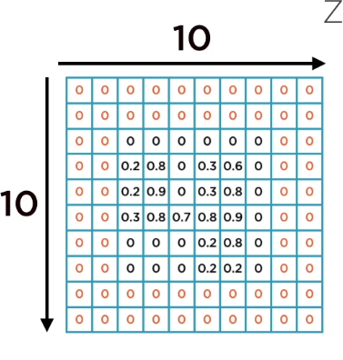
    - narrow vs wide convolution
      - narrow – little zero padding – fewer convolution outputs than inputs
        - sometimes ignores adges
      - wide – lots of zero-padding – more (or equal) convolution outputs than inputs
        - use when edges are as important as middle
    - stride size – how far do you slide the window with each step
      - how often each element is considered
      - horizontal and vertical stride for a 2D matrix
      - how often filter is applied (can be used to reduce complexity)
    - paramter explosion – dense networks result in a huge increase in parameters with various weights and biases if fully connected (e.g. 28x28 image can result in 100K + parameters in NN)– can be fixed with convolution
      - feature/pattern recognition independent of location

    - Pixels >> Lines >> Contours/Edges >> Object
      - e.g. kernel/filter with 1s in horizontal row of matrix will result in feature map neuron that detects horizontal lines
    - feature map – matrix of neurons that respond to parts of data matrix
      - neurons may have a different filter/kernel
      - small kernels are more efficient (e.g. 3#3x3 > 1#9x9)
      - several feature maps are grouped together to generate a single convolution layer with different parameters in each feature map
      - each neuron in feature map includes the feature maps of previous layers
    - activation function is typically ReLU
  - input pooling – subsampling convolution output to extract information
    - no weights or biases (no params) –
    - applies an aggregation function to all inputs – extract most relevant features (looks like downsampling)
    - reduces memory usage
    - reduces overfitting
    - location invariance – subsampling enables recognition independent of location
    - output is always smaller than input – depth is the same (or deeper)
  - Structure
    - alternating groups of covolution layers and pooling layers
    - DNN layers are tradtional feed-forward
      - ReLU activation
      - final layer using softmax (for classification prediction)
- Hands-on machine learning with scikit-learn and tensorflow - Aurélien Géron
  - https://github.com/ageron/handson-ml/blob/master/13_convolutional_neural_networks.ipynb
- can print out the shapes for layers?
- Pooling over batch_size, height, width, channels
  - strides specified as [batch (not supported), horiz, vert, channels
- flatten result of pooling layer prior to passing to DNN
- final layer is sparse with softmax activation (part of cost function) – implicit in sparse softmax cross entropy with logits cost function
- saving was done with a tf.train.Saver()
- manual looping through epochs

CIFAR-10 dataset with CNN with dropout
  - www.cs.toronto.edue/~kriz/cifar.html (alexnet creator)
    - http://goo.gl/5jz5xC (tar.gz)
      - pickle files within
  - 10 classes of objects: airplane, auto, bird, cat, deer, dog, frog, horse, ship, truck
  - 32x32 color images (3 channels) in 10K batches
    - labels mapped to numbers
  - pull data from web
  - steps
    - load data
    - X placeholder
    - dropout layer -set rate – only applies during training
    - convolution layer with 32 feature maps, 3x3 kernel
    - 2nd convolution layer with 64 feature maps, stride 2
    - pooling layer (max) – padding ='VALID' (no padding)
    - 3rd convolution – 128 feature maps, 4x4 kernel, strides=3
    - 2nd pooling layer (max) VALID again (no padding)
    - flatten final pooling layer
    - DNN layer 128 neurons (relu)
    - dense layer2 with 64 neurons (relu)
    - dense layer 10 neurons for softmax
      - softmax part of loss function passed to tf.reduce_mean
      - adam optimizer
    - feed data to training in batches (done with function)
      - 80% of each batch used for training
    - manually run through epochs with training flag set (to enable dropout)
      - set training flag = false for predicting
    - images are complex so ~35% accuracy is good, ~48% is excellent
      - improve via
        - more training batches
        - changing architecture of conv or pool layers
        - change # kernels or feature maps in convolution layers or strides
        - increased # epochs for training

Recurrent Neural Network (RNN)
- good for time series – cause-> effect – time relationships can have special meaning
  - time series, sentence context, predicting movement
  - auto-regressive – if past values effect current values
- BPTT back-propogation through time
- Recurrent neurons – output of step is fed back to input (memory)
  - in addition to input receives output of the previous time period (x_{t} and y_{t-1})
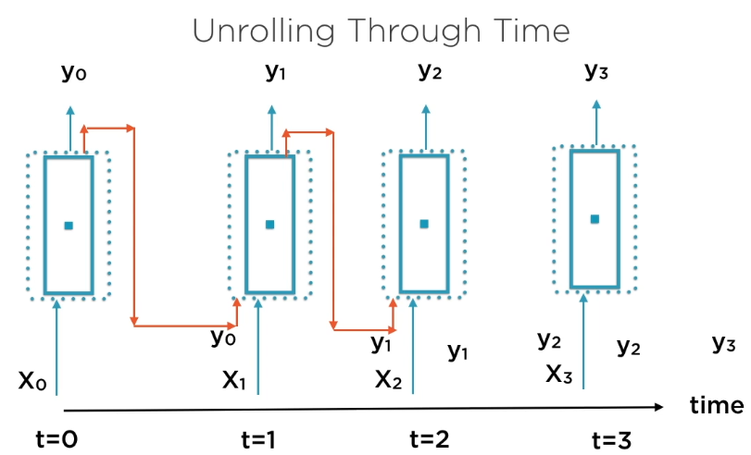
  - recurrent neuron 'unrolled through time'
  - both inputs and outputs are vectors (no dim reduction as with FFNN) – last one is the most important (the prediction)
  - storing state – the preivous time instance – could store more than just 1 prior time instance
    - e.g. LSTM (long short term memory)
  - 2 inputs so 2 weight vectors for activation function &phi;
  - memory cell – layer of recurrent neurons (LSTM or GRU)
    - layer can be unrolled through time (just like neuron) – layer looks at all time obs
    - 1 layer for each time instance?
    - Optimization through gradient descent – weights/biases converge to final values
      - fails when gradients don't change (vanishing) or change too fast (exploding)
  - RNN challenges
    - large depth due to consideration of large amount of past data – multiple levels of unrolling
      - more prone to vanishing/exploding gradient problems
      - manage with:
        - proper initialization (better than random)
        - non-saturating activation function (e.g. leaky relu, [ELU] exp lin unit)
        - batch normalization – scale and shift around 0
        - gradient clipping – clips gradient at a thresh for every step
        - truncated BPTT – discard distant past – risky - retaining distant past otherwise more unrolling through time (limit input data)
        - add long-term memory to basic RNN cells (LSTM)
  - RNN on MNIST
    - shape = (batch_size, n_steps – time periods, n_inputs – data at each time period)
    - for an image – structure data such that every row represents a step in time
      - e.g. 28x28 image = 28 time instances with 28 inputs
    - 150 neurons per layer – 28 layers with 28 inputs – 10 final outputs (1 for each digit)
    - steps
      - X placeholder (deprecated)
      - y placeholder
      - basic unit is a 'cell factroy' tf.contrib.rnn.BasicRNNCell(num_units)
        - there are also LSTM factories
        - handles creating additional layers as we move through time – created via tf.nn.dynamic_rnn(cell, X, dtype)
          - returns outputs and final memory states for all cells (last output)
        - mitigates out-of-memory errors
      - final softmax layer for classification
        - adam optimizer
      - reshape inputs for processing (for each batch)
      - set up epoch loop and run training
  - Long Memory
    - advantages
      - better training performance
      - less prone to exploding/vanishing gradients
      - weights/biases converge faster
      - no need to truncate BPTT –
    - holding more internal state – more memory – remember more prior outputs
      - explicit addition: c=long term state, h=short-term state
      - updates both short and long term memory with each iteration
      - forget unimportant old memories
      - create important new memories
      - 4 gate [NNs] – element-wise multiplication of 2 vectors
        - forget gate
        - main
        - input gate
        - output gate
      - variants
        - peephole connections – store state for more than 1 period
        - GRU (gated recurrent unit) – simplified LSTM with better performance
          - 1 state vector
          - fewer internal gates and NNs
  - text sequential data – context is important
    - repsresenting text as numbers – tensor of word encodings
      - tokenize then encode each word
      - one-hot – all words in corpus become columns – each word marked with 1
        - large data size
        - order is lost
        - frequency information lost
      - TF-IDF – term frequency times inversion document frequency
        - term frequency – how often word appears I document
        - IDF = how infrequently word appears in entire corpus
        - high score = many occurrences in this document but rare in corpus as a whole
        - smaller data size
        - freq and relevance captured
        - order/context is lost
      - Word embeddings – huge corpus – words that are frequently found together
        - very low dimensionality
        - each word is represented by the vector of similar words
        - generated from unsuperfvised learning – clustering or dim reduction
    - DBPedia dataset – standard tensorflow example – ships with tensorflow (also: wiki.dbpedia.org/Datasets (500K rows) – 15 output classes
      - vocabulary processor from tensorflow that gives each word an ID
        - each word encoded to a vector which is used by RNN
      - requires distributed system to run (Cloud etc.)
      - shuffle the data
      - create train and test datasets
      - set 'document' size = e.g. find the longest paragraph – pad shorter docs [truncate longer ones]
      - encode words with tf.contrib.learn.preprocessing.VocabularyProcessor
      - building a custom estimator – estimator spec – parameters that define/configure the model
        - define prediction mode
        - define training mode – with loss function and adam optimizer
        - evaluation mode – with accuracy calculation for comparison and loss function
      - find word vector encodings tf.contrib.layers.embed_sequence
      - change dimensions of data with tf.unstack
      - use GRU cell tf.contrib.rnn.GRUCell
      - factory = tf.contrib.rnn.static_rnn(cell, word_list, dtype)
        - more prone to out-of-memory compared with dynamic_rnn
      - create estimator with model
      - pass in input data for training – use numpy_input_fn

